Official league roster - Basketball
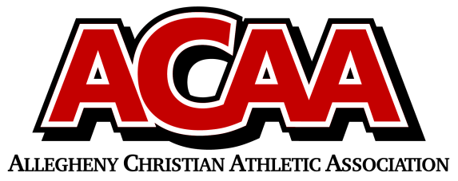

School Name: CACS
Team Colors: Black, White, Red
Overall Wins ___ Losses ____ Ties ___
ACAA Wins ___ Losses ____ Ties ___ OPPONENT: __________________________
Date: _________
Number | Name | Year | Position | Height | Homeschool
32 | Noah Michael | 12 | G | 5’ 11’’
20 | Eli Mann | 11 | C | 5’ 11”
3 | Stephen Manno | 11 | G | 5’ 8’’
14 | Liam Ramkawsky | 11 | G | 5’ 11’’
2 | Blake McGarry | 10 | F | 5’ 2’’
21 | DJ Hudson | 9 | F | 5’ 10’’
44 | Luke Smeal | 10 | G | 5’ 2”
24 | Michael Tubbs | 9 | G | 5’4’’
23 | Danny Finney | 9 | G | 5’ 7”
50 | Gideon Korb | 7 | C | 5’8’’
1 | Colton Sass | 6 | PG | 5’ 8”
42 | Jace Luzier | 6 | G | 5’ 2’’
35 | Cayden Hann | 6 | F | 5’ 2’’
40 | Euguene Fenush | 6 | G | 5’ 0’’
31 | Colt Smeal | 6 | PG | 5’ 0’’

Head Coach: Chris Michael
Asst. coach: Dan smeal
Asst. coach:

Official ACAA League Team Roster. to be submitted to the scorer’s table before each game.

